 COSC 1320
Name: _________________ Terminal #_

Programming Assignment 2 JAVA Acceptance:
After you downloaded your zipped project from BB and run it using the 200 PGH NetBeans 6.9.1 , download the “Programming Assignment 2 Acceptance Testing.doc” from PROGRAMMING ASSIGNMENT 2 TESTING Blackboard Assignment and run the following test cases, take screenshots of the output produced, and insert in this file ……..
1. Include your UML USE CASE Diagram MODEL:
Attached to BB with acceptance testing.

2. Include your UML MVC CLASS Diagram MODEL:

Attached to BB with acceptance testing.

3. Select the items as below
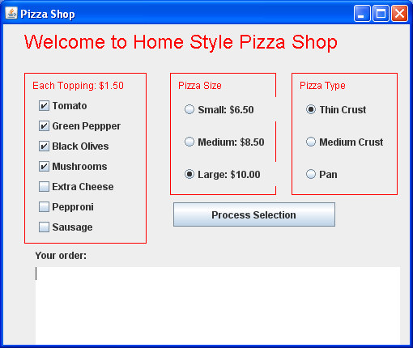
A screenshot of your output:
SCREENSHOT Output of your PROJECT is:
On next page.
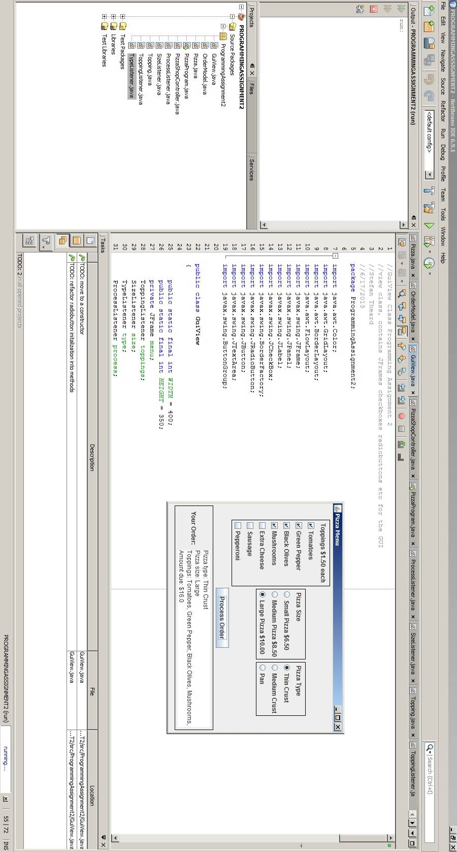

4. Select the items as below
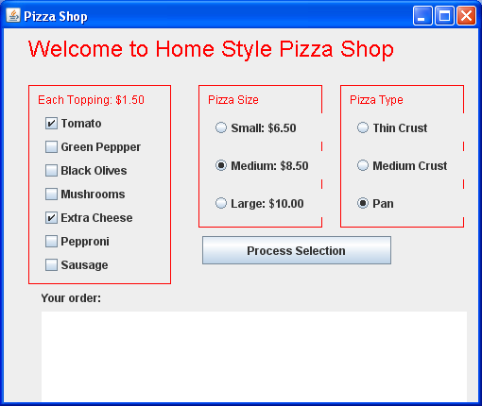
A screenshot of your output:
SCREENSHOT Output of your PROJECT is:

On next page.
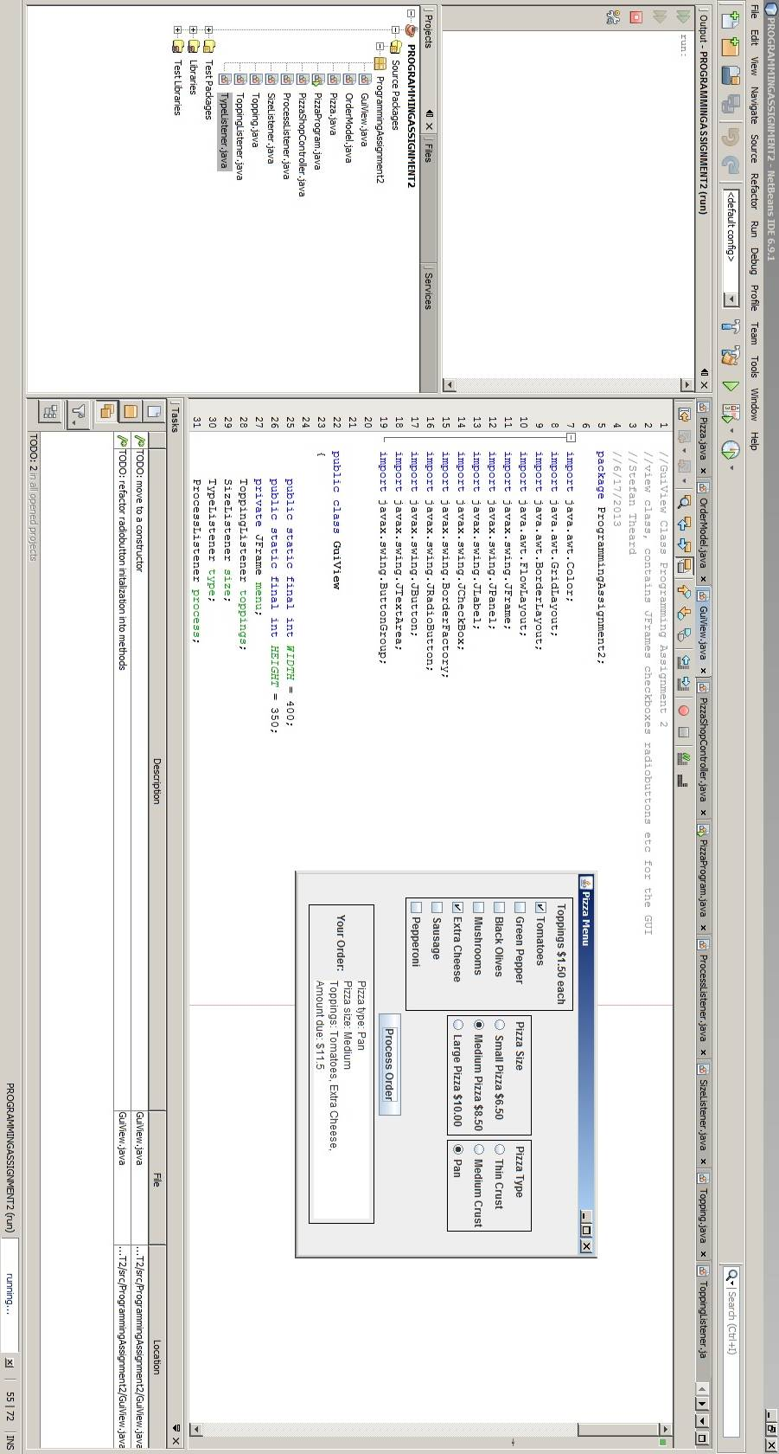
5. Copy and paste .java source code here:

//PizzaProgram Class Programming Assignment 2
//contains main which initiates the gui via the view
//Stefan Theard
//6/17/2013
package ProgrammingAssignment2;

public class PizzaProgram
{
public static void main(String[] args)
{
GuiView view = new GuiView();
PizzaShopController controller = new PizzaShopController();
ToppingListener toppingListener = new ToppingListener(controller);
SizeListener sizeListener = new SizeListener(controller);
TypeListener typeListener = new TypeListener(controller);
ProcessListener processListener = new ProcessListener(controller, view);
view.initGui(toppingListener, sizeListener, typeListener,
processListener);
}
}

//GuiView Class Programming Assignment 2
//view class, contains JFrames checkboxes radiobuttons etc for the GUI
//Stefan Theard
//6/17/2013
package ProgrammingAssignment2;

import java.awt.Color;
import java.awt.GridLayout;
import java.awt.BorderLayout;
import java.awt.FlowLayout;
import javax.swing.JFrame;
import javax.swing.JPanel;
import javax.swing.JLabel;
import javax.swing.JCheckBox;
import javax.swing.BorderFactory;
import javax.swing.JRadioButton;
import javax.swing.JButton;
import javax.swing.JTextArea;
import javax.swing.ButtonGroup;

public class GuiView
{

public static final int WIDTH = 400;
public static final int HEIGHT = 350;
private JFrame menu;
ToppingListener toppings;
SizeListener size;
TypeListener type;
ProcessListener process;
JTextArea displayTextArea;

public void initGui(ToppingListener toppings, SizeListener size,
TypeListener type, ProcessListener process)
{
//TODO: move to a constructor
this.toppings = toppings;
this.size = size;
this.type = type;
this.process = process;

initFrame();
initToppingsPanel();

JLabel sizeLabel = new JLabel(" Pizza Size ");
JLabel typeLabel = new JLabel(" Pizza Type ");

//TODO: refactor radiobutton initalization into methods
//Size radio buttons begin here
JPanel sizePanel = new JPanel(new GridLayout(0, 1));
sizePanel.add(sizeLabel);
sizePanel.setBorder(BorderFactory.createLineBorder(Color.black));
JRadioButton smButton = new JRadioButton("Small Pizza $6.50");
JRadioButton mdButton = new JRadioButton("Medium Pizza $8.50");
JRadioButton lgButton = new JRadioButton("Large Pizza $10.00");
//set small selected as default and add buttons to a group
smButton.setSelected(true);
ButtonGroup sizeGroup = new ButtonGroup();
sizeGroup.add(smButton);
sizeGroup.add(mdButton);
sizeGroup.add(lgButton);
//add to panel
sizePanel.add(smButton);
sizePanel.add(mdButton);
sizePanel.add(lgButton);
//adding listeners
smButton.addActionListener(size);
mdButton.addActionListener(size);
lgButton.addActionListener(size);
menu.add(sizePanel);

// Type radio buttons begin here
JPanel typePanel = new JPanel(new GridLayout(0, 1));
typePanel.add(typeLabel, BorderLayout.NORTH);
typePanel.setBorder(BorderFactory.createLineBorder(Color.black));
JRadioButton thinCrust = new JRadioButton("Thin Crust");
JRadioButton medCrust = new JRadioButton("Medium Crust");
JRadioButton panCrust = new JRadioButton("Pan");
//set thin selected as default and add buttons to group
thinCrust.setSelected(true);
ButtonGroup typeGroup = new ButtonGroup();
typeGroup.add(thinCrust);
typeGroup.add(medCrust);
typeGroup.add(panCrust);
//adding listeners
thinCrust.addActionListener(type);
medCrust.addActionListener(type);
panCrust.addActionListener(type);
//add to panel
typePanel.add(thinCrust);
typePanel.add(medCrust);
typePanel.add(panCrust);
menu.add(typePanel);

//Process Order button begins here
JButton processOrder = new JButton("Process Order");
//adding listener
processOrder.addActionListener(process);
menu.add(processOrder, BorderLayout.SOUTH);

initTextPanel();

menu.setVisible(true);
}

private void initFrame()
{
menu = new JFrame();
menu.setSize(WIDTH, HEIGHT);
menu.setDefaultCloseOperation(JFrame.DISPOSE_ON_CLOSE);
menu.setTitle("Pizza Menu");
menu.setLayout(new FlowLayout());
}

public void updateDisplay(OrderModel order)
{
String orderSummary = "";
orderSummary = orderSummary + "Pizza type: " + order.getType() + "\n";
orderSummary = orderSummary + "Pizza size: " + order.getSize() + "\n";

orderSummary = orderSummary + "Toppings: ";
for(Topping topping : order.pizza.selectedToppings)
orderSummary = orderSummary + topping + ", ";

orderSummary = orderSummary + "\nAmount due: $" + order.getCost();
displayTextArea.setText(orderSummary);
}

private void initToppingsPanel()
{
String[] toppingNames = {"Tomatoes", "Green Pepper", "Black Olives",
"Mushrooms", "Extra Cheese", "Sausage", "Pepperoni"};
JLabel toppingLabel = new JLabel(" Toppings $1.50 each ");
JPanel toppingPanel = new JPanel(new GridLayout(0, 1));
toppingPanel.add(toppingLabel, BorderLayout.NORTH);
toppingPanel.setBorder(BorderFactory.createLineBorder(Color.black));

for(String topping : toppingNames)
{
JCheckBox toppingCheckBox = new JCheckBox(topping);
toppingCheckBox.addActionListener(toppings);
toppingPanel.add(toppingCheckBox);
}

menu.add(toppingPanel);
}

private void initTextPanel()
{
JLabel textLabel = new JLabel(" Your Order: ");
JPanel textPanel = new JPanel();
displayTextArea = new JTextArea(4, 25);
displayTextArea.setEditable(false);
textPanel.add(textLabel, BorderLayout.NORTH);
textPanel.add(displayTextArea);
textPanel.setBorder(BorderFactory.createLineBorder(Color.black));

menu.add(textPanel);
}
}
//PizzaShopController Class Programming Assignment 2
//generic controller class, redirects to model
//Stefan Theard
//6/17/2013
package ProgrammingAssignment2;

public class PizzaShopController
{

public OrderModel order = new OrderModel();

public void UCchooseTopping(String topping)
{
order.setTopping(topping);
}

public void UCchooseSize(String size)
{
order.selectSize(size);
}

public void UCchooseCrust(String crust)
{
order.selectCrust(crust);
}

public void UCprocessOrder()
{
order.processOrder();
}
}

//OrderModel Class Programming Assignment 2
//main processing model does all of the heavy lifting
//Stefan Theard
//6/17/2013
package ProgrammingAssignment2;

public class OrderModel
{
private double totalCost = 0.00;
private double toppingPrice = 1.50;
private double smPrice = 6.50;
private double medPrice = 8.50;
private double lgPrice = 10.00;
public Pizza pizza = new Pizza();

public void setTopping(String topping)
{
if(pizza.hasTopping(topping))
{
pizza.removeTopping(topping);
}else{
pizza.addTopping(topping);
}
}

public void selectSize(String size)
{
if(size.equals("Small Pizza $6.50"))
pizza.setSize("Small");
else if(size.equals("Medium Pizza $8.50"))
pizza.setSize("Medium");
else if(size.equals("Large Pizza $10.00"))
pizza.setSize("Large");
}

public void selectCrust(String crust)
{
pizza.setType(crust);
}

public void processOrder()
{
totalCost = pizza.selectedToppings.size() * toppingPrice;

if(pizza.getSize().equals("Large"))
totalCost = totalCost + lgPrice;
else if(pizza.getSize().equals("Medium"))
totalCost = totalCost + medPrice;
else if(pizza.getSize().equals("Small"))
totalCost = totalCost + smPrice;
}

public double getCost()
{
return totalCost;
}

public String getType()
{
return pizza.getType();
}

public String getSize()
{
return pizza.getSize();
}
}

//Pizza Class Programming Assignment 2
//another model, holds the state of toppings
//Stefan Theard
//6/17/2013
package ProgrammingAssignment2;
import java.util.ArrayList;
public class Pizza
{
private final String[] availableToppingNames = {
"Tomatoes",
"Green Pepper",
"Black Olives",
"Mushrooms",
"Extra Cheese",
"Sausage",
"Pepperoni"
};
private String size = "Small";
private String type = "Thin Crust";
public Topping[] availableToppings;
public ArrayList<Topping> selectedToppings;

public Pizza()
{
availableToppings = new Topping[availableToppingNames.length];
for(int i = 0; i<availableToppingNames.length; i++)
{
availableToppings[i] = new Topping(availableToppingNames[i]);
}
selectedToppings = new ArrayList<Topping>();
}

public String getSize()
{
return size;
}

public String getType()
{
return type;
}

public void setSize(String newSize)
{
size = newSize;
}

public void setType(String newType)
{
type = newType;
}

public void addTopping(String toppingName)
{
selectedToppings.add(new Topping(toppingName));
}

public void removeTopping(String toppingName)
{
selectedToppings.remove(new Topping(toppingName));
}

public boolean hasTopping(String toppingName)
{
return selectedToppings.contains(new Topping(toppingName));
}
}
//Topping Class Programming Assignment 2
//holds name of a topping
//Stefan Theard
//6/17/2013
package ProgrammingAssignment2;

public class Topping
{
private String name;
public Topping(String name)
{
this.name = name;
}

public String toString()
{
return name;
}

public boolean equals(Object other)
{
return name.equals(other.toString());
}
}

//SizeListener Class Programming Assignment 2
//generic listener
//Stefan Theard
//6/17/2013
package ProgrammingAssignment2;

import java.awt.event.ActionListener;
import java.awt.event.ActionEvent;

public class ProcessListener implements ActionListener
{
private PizzaShopController controller;
private GuiView view;

public ProcessListener(PizzaShopController controller, GuiView view)
{
this.controller = controller;
this.view = view;
}
public void actionPerformed(ActionEvent e)
{
controller.UCprocessOrder();
view.updateDisplay(controller.order);
}
}

//SizeListener Class Programming Assignment 2
//generic listener
//Stefan Theard
//6/17/2013
package ProgrammingAssignment2;

import java.awt.event.ActionListener;
import java.awt.event.ActionEvent;

public class SizeListener implements ActionListener
{
private PizzaShopController controller;

public SizeListener(PizzaShopController controller)
{
this.controller = controller;
}
public void actionPerformed(ActionEvent e)
{
controller.UCchooseSize(e.getActionCommand());
}
}

//TypeListener Class Programming Assignment 2
//generic listener
//Stefan Theard
//6/17/2013
package ProgrammingAssignment2;

import java.awt.event.ActionListener;
import java.awt.event.ActionEvent;

public class TypeListener implements ActionListener
{
private PizzaShopController controller;

public TypeListener(PizzaShopController controller)
{
this.controller = controller;
}
public void actionPerformed(ActionEvent e)
{
controller.UCchooseCrust(e.getActionCommand());
}
}

//ToppingListener Class Programming Assignment 2
//generic listener
//Stefan Theard
//6/17/2013
package ProgrammingAssignment2;

import java.awt.event.ActionListener;
import java.awt.event.ActionEvent;

public class ToppingListener implements ActionListener
{
private PizzaShopController controller;
public ToppingListener(PizzaShopController controller)
{
this.controller = controller;
}
public void actionPerformed(ActionEvent e)
{
controller.UCchooseTopping(e.getActionCommand());
}
}

When done attach this file to “PROGRAMMING ASSIGNMENT 2 TESTING” BB Assignment.

